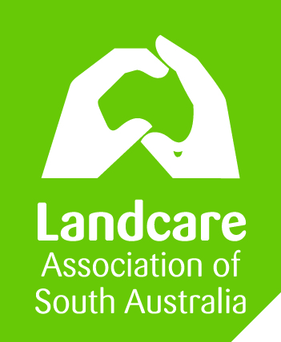
Code of Conduct
for community environmental groups

Template 023
VERSION 1-SA 1.3.2016

The Code of Conduct applies to all financial members, volunteers and employees (‘members’) of XYZ Community Group while undertaking any role or activity related to XYZ Community Group.

Purpose | The Code of Conduct contains standards of behaviour expected at XYZ Community Group. It is a central guide and reference to support day-to-day decision making and reflects the purpose, mission and values of XYZ Community Group.
Our Principles | The Code of Conduct is based on the following fundamental ethical principles:  - Respect for the Law  XYZ Community Group members, in common with all citizens, are under the jurisdiction of the laws of the State and the Commonwealth and are obliged to observe such laws.  - Respect for all Persons  XYZ Community Group recognises that its primary responsibility is to Landcare members however, XYZ Community Group commits to treat all members of the community equitably, with dignity and respect. This involves, but is not limited to, the following:  - Tolerance of the views held by others which are different from your own;  - Courtesy and responsiveness in dealing with others;  - Fairness in supervising and dealing with other members;  - Making decisions that are procedurally fair to all people according to the principles of natural justice;  - Not discriminating on grounds such as gender, sexual orientation, race, ability, cultural background, religious status, marital status, age or political conviction;  - An awareness and respect for cultural difference;  - Allowing for alternative points of view to be expressed;  - Not engaging in behaviour that might reasonably be perceived as harassment, bullying or intimidation; and  - Not engaging in conduct likely to bring discredit upon XYZ Community Group.  - Integrity  XYZ Community Group members should carry out their duties in the best interests of XYZ Community Group and avoid conflicts between their private interests and their Landcare responsibilities with respect to:  - Personal relationships;  - Financial relationships;  - Receipt of gifts;  - Outside work;  - Use of confidential information obtained in the course of Landcare duties; and  - External activities and public comment.  - Diligence  XYZ Community Group members should carry out their duties in a professional and conscientious manner. This involves:  - Always acting honestly, in good faith, and in the best interest of XYZ Community Group;  - Carrying out official decisions and policies faithfully and impartially;  - Seeking to attain the highest possible standards of performance;  - Exercising care for others in Landcare-related activities; and  - Committee members have an obligation to be independent in judgement and action and to take all reasonable steps to be satisfied as to the soundness of all decisions taken by the Committee.  - Conflict of Interest  XYZ Community Group members must declare interests which conflict, either perceived or actual, with XYZ Community Group duties and activities. Members must not allow personal interests, or the interests of any associated person, to conflict with the interests of XYZ Community Group.  A conflict of interest may include, but is not limited to, an expressed personal value or belief, professional ethics, personal or professional relationships, financial or proprietary interests.  - Confidentiality  XYZ Community Group acknowledges that confidential information received in the course of the exercise of official duties remains the property of XYZ Community Group.  In addition, it is improper to disclose confidential information, or allow it to be disclosed, unless that disclosure has been authorised by XYZ Community Group or the person from whom the information is provided, or is required by law.  Documents and information of XYZ Community Group should be placed in secure locations where possible and sensitive information should not be distributed without the Chairperson’s consent.
Grievances, Complaints and Procedures | Breaches of this Code of Conduct or other policies of XYZ Community Group will be addressed by way of the Grievance Policy.  XYZ Community Group members should familiarise themselves with this Code of Conduct and endeavour to ensure that its principles are observed at all times.
 |  | AUTHORISATION:
 |  | This version was approved on: | Click here to enter a date.
 |  | This version takes effect on: | Click here to enter a date.
 |  | Authorised by: | Insert name
 |  | Chairperson: | Insert name
 |  | Chairperson signature:

DISCLAIMER: The information contained in this publication is based on knowledge and understanding at the time of March 2016. However, because of advances in knowledge, users are reminded of the need to ensure that information upon which they rely is up to date and to check currency of the information with the appropriate officer of LASA or the user’s independent advisor.

Landcare in a Box: an initiative of the National Landcare Network resourced by Landcare NSW and funded originally by NSW DPI.

