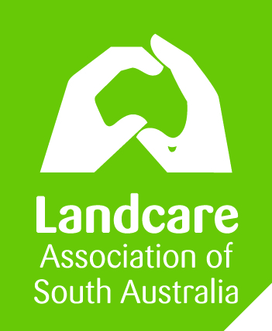
Social Media Policy
for community environmental groups
Template 004
VERSION 2-SA 1.03.2016

Introduction | Social media provides XYZ Community Group with the opportunity to engage in ongoing conversations with its diverse stakeholder base. It allows XYZ Community Group to connect with the community, improve our understanding of current attitudes and issues and share Landcare activities and programs.  XYZ Community Group supports its employees’ and volunteers’ participation in social media as a means of complementing traditional communication channels (e.g. web, print, radio, television).
Definition | Social Media refers to the platforms of Facebook, Twitter, Instagram, YouTube, MySpace, LinkedIn and Pinterest.
Scope of  Social Media Use | This policy applies to all staff, contractors and committee of XYZ Community Group. It applies to these uses of social media:  - Creating a social media presence as an official representative of XYZ Community Group;  - Publishing messages, responding to comments + uploading content, including data, to official, public facing XYZ Community Group social media channels and / or third party social media channels;  - Making reference to XYZ Community Group within a private capacity on social media; and  - When a staff member participates in discussion that relates directly or indirectly to the field in which they are employed by XYZ Community Group.
Principles of  Conduct | Importantly, all content posted on social media sites immediately becomes public information, freely available to those who access it and potentially permanent, difficult to erase, remove or retract.  Staff use of social media should adhere to the same standard of professional practice and conduct associated with all communication activities. Staff are to operate within the XYZ Community Group’s social media policy and within the professional standard of the XYZ Community Group Code of Conduct. This includes:  - Be honest, polite and considerate  - Be apolitical and impartial when using social media for official purposes.  - Demonstrate the values of XYZ Community Group.  - Staff must not do anything that may adversely affect XYZ Community Group, or use social media in a way that could bring XYZ Community Group into disrepute. This may lead to disciplinary action.  - All staff and committee must exercise caution and adopt a risk minimisation approach when using social media.
Official Use of  Social Media | Staff / volunteers participating in an official capacity on third party or XYZ Community Group hosted social media platforms must:  - Have the prior consent of the General Manager to act as an authorised social media user.  - Only post or discuss information that is publicly available.  - Disclose in a manner suitable to the platform that they are an employee / volunteer of XYZ Community Group and specify their role within XYZ Community Group.  - Do not mix personal views with official comments.  - Inform the General Manager of any media involvement or interest by journalists.  - Follow and comply with the requirements of existing XYZ Community Group policies.  - Ensure there is no conflict of interest for XYZ Community Group.  - Contribute to reporting on the performance of social media channels against XYZ Community Group targets for community engagement.
Private Use of  Social Media | Staff / committee participating in social media in a private capacity are expected to:  - Exercise sound judgement and behave in accordance with XYZ Community Group policy, values and Code of Conduct.  - Clearly separate private opinions from the XYZ Community Group official position.  - Not allow the use of social media to undermine their effectiveness at work.  - Use a private social media account, established with a private email address (staff / committee must not use a XYZ Community Group social media account or a XYZ Community Group email address for private use of social media).  - Not disclose confidential information obtained through work.  - Understand the risks, benefits and implications that may arise from making private contributions to discussions that relate to their work.  - Seek advice from the General Manager to address any issues or concerns.
Role of the General Manager / Chairperson | Roles of the General Manager in relation to social media include:  - Maintain a register of official social media accounts and channels.  - Arrange social media training where appropriate.  - Advise on and approve social media content frameworks.  - Track and monitor discussions and respond to emerging issues.  - Ensure that any staff / volunteers who are authorised to operate social media are aware of this policy.  - Ensure adherence to protocols such as photo release forms + Child Protection Guidelines.  - Oversee the use of social media tools.  - Maintain internal processes to ensure quality, technical accuracy and currency of content posted to social media sites.  - Authorise staff / volunteers to represent XYZ Community Group in approved social media channels.
 |  | AUTHORISATION:
 |  | This version was approved on: | Click here to enter a date.
 |  | This version takes effect on: | Click here to enter a date.
 |  | Authorised by: | Insert name
 |  | Chairperson: | Insert name
 |  | Chairperson signature:

DISCLAIMER: The information contained in this publication is based on knowledge and understanding at the time of March 2016. However, because of advances in knowledge, users are reminded of the need to ensure that information upon which they rely is up to date and to check currency of the information with the appropriate officer of LASA or the user’s independent advisor.

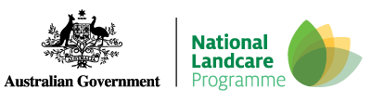
Landcare in a Box: an initiative of the National Landcare Network, resourced by Landcare NSW and originally funded by NSW DPI.

